The Ohio State University

Colleges of the Arts and Sciences New Course Request

Department of Geological Sciences

Academic Unit
Geological Sciences

Book 3 Listing (e.g., Portuguese)
411 Water Security for the 21st Century
Number Title
Water Security U 05
18-Character Title Abbreviation Level Credit Hours

Summer Autumn Winter Spring X Year 2007
Proposed effective date, choose one quarter and put an “X” after it; and fill in the year. See the OAA curriculum manual for deadlines.

A. Course Offerings Bulletin Information

Follow the instructions in the OAA curriculum manual. If this is a course with decimal subdivisions, then use one New Course Request form for the generic information that will apply to all subdivisions; and use separate forms for each new decimal subdivision, including on each form the information that is unique to that subdivision. If the course offered is less than a quarter or a term, please complete the Flexibly Scheduled/Off Campus/Workshop Request form.

Description (not to exceed 25 words): This course examines the major issues that are contributing to the decline

In quantity and quality of global freshwater resources and the resultant environmental and societal impacts.

Quarter offered: Spring Distribution of class time/contact hours: 2, 2-hr and 1,1-hr classes/wk
Quarter and contact/class time hours information should be omitted from Book 3 publication (yes or no): No

Prerequisite(s): GEC data analysis course; sophomore standing and above
Exclusion or limiting clause:

Repeatable to a maximum of __NA___ credit hours.

Cross-listed with:

Grade Option (Please check): Letter X S/U Progress What is course is last in the series? ______

Honors Statement: Yes No X GEC: Yes No X Admission Condition
Off-Campus: Yes No X EM: Yes No X Course: Yes No X

Other General Course Information:
(e.g. “Taught in English.” “Credit does not count toward BSBA degree.”)

B. General Information

Subject Code________________________ Subsidy Level (V, G, T, B, M, D, or P)___________________________
If you have questions, please email Jed Dickhaut at dickhaut.1@osu.edu.

1. Provide the rationale for proposing this course:
See Attached

2. Please list Majors/Minors affected by the creation of this new course. Attach revisions of all affected programs. This course is (check one): Required on major(s)/minor(s) XA choice on major(s)/minors(s)
An elective within major(s)/minor(s) A general elective:

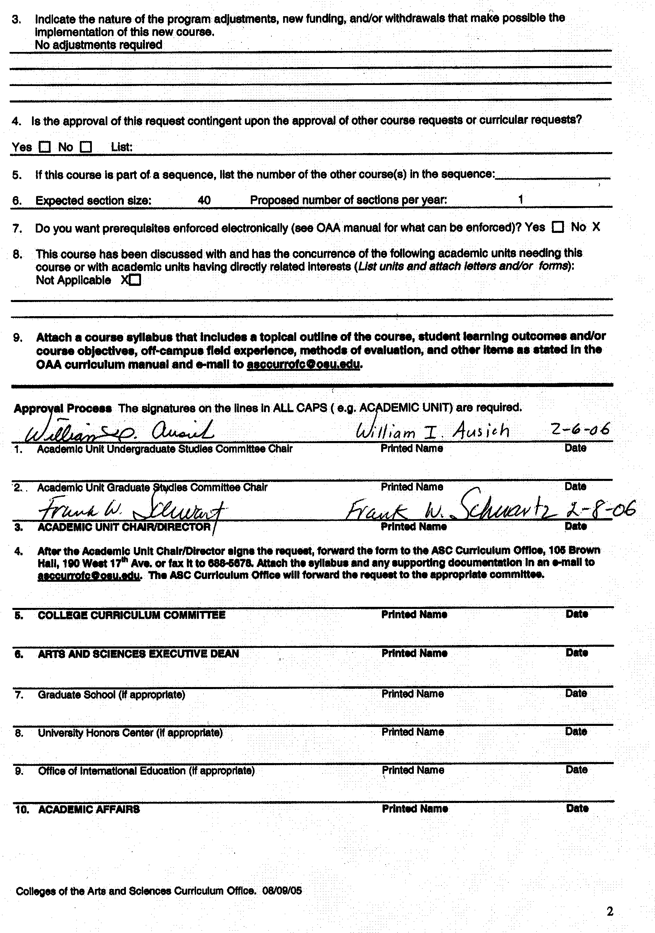

Rationale for Geol Sci 411

Water Security for the 21st Century

Rationale: The Earth’s freshwater supply will be the foremost critical natural resource issue facing humanity in the 21st century. There is irrefutable evidence of an emerging global water crisis that threatens lives, sustainable development, and even peace and security. In the new millennium, the world’s population and per-capita demand for freshwater resources will continue to increase even though the supply never changes. It is a finite, but renewable resource that is increasingly being over utilized or degraded on a global scale.
Earth is the blue or water planet, but of the approximately 2.5% of the Earth’s water that is fresh, less than 1% is readily available for human use from lakes, rivers, and groundwater aquifers. More importantly, the supply of freshwater is not evenly distributed across the globe. One-fifth of the world’s population today has no access to safe drinking water and half of all people have poor or unsafe water sanitation. If present consumption patterns continue and population grows to an estimated 8 billion, it is estimated that two out of every three persons will live in water-stressed conditions by 2025. Disturbingly, many of the countries of Sub-Saharan Africa and western and southern Asia that are already under water-stress conditions or have unsustainable rates of withdrawal, also contain the largest, fastest growing, poorest, and most politically unstable populations on the globe.
Although freshwater resources are shrinking in quantitative and qualitative terms, a crisis is not inevitable. The world needs sustainable water management. Critical water issues and impacts must be recognized and coupled with a strong and committed move to a new direction. Foremost, this will require an understanding by the public of what the problems are, what they mean to their well-being, and how they can be confronted to maintain and improve living standards. Knowledge, recognition, and concerns for water problems facing the world can help force the political will to avert crises and develop the commitments needed to assure humanity’s survival.
This undergraduate level course on Water Security for the 21st Century is necessary to provide students with the basic foundation and broader perspective required for other courses in the geological sciences as well as more advanced courses in water-related topics. Students outside geological sciences will benefit from this introductory-level course through an increased awareness of the impacts freshwater resources have on global human and ecological health, economics, and political issues. It is anticipated that enrollment for this course will grow steadily from less than 10, to 30 or more with increasing departmental and university exposure.

NEW COURSE SYLLABUS

College of the Arts and Sciences
Dept. of Geological Sciences
Course Number/Title: 411 Water Security for the 21st Century
Instructor/Lectures: Dr. Motomu Ibaraki

Graduate Teaching Associate: TBD

Required Text/Reading List: This is an extremely current subject. Consequently, a textbook is not required for the class; literature readings and website information will be provided or placed on reserve in Orton Library.

Credit: 5 Credit Hours

Prerequisite: GEC data analysis course; sophomore standing and above.

Course Structure: Two, 2-hour lectures and one, 1-hour lecture /week

Description: This course examines the major issues that are contributing to the decline in quantity and quality of global freshwater resources and the resultant environmental and societal impacts.

Content: This course will provide a broad introduction to the critical issues relating to the world’s freshwater resources. A wide range of freshwater resource issues and water policy topics will be presented in a combination lecture and interactive seminar, group or individual project, and exercise format. Current and past scientific and popular literature articles and website information focusing on a particular water issue will be assigned each week for class review and discussion. Students will develop an awareness and fundamental understanding of the interrelations between freshwater resources and past, present, and projected environmental, socioeconomic, and political conditions. Following an introduction to basic principles and concepts of the hydrological cycle, subsequent lectures will address a range of problems from drought and climate change to competition for and contamination of scarce freshwater supplies.

Course Objectives: The overall objective of this course is to introduce students to and foster discussion on the many scientific and political facets of the world’s leading freshwater issues. Additionally, upon successful completion of the course, students will have developed an understanding of fundamental climatological and hydrological principles.

Course Grades: The course will be graded according to results from examinations, exercises, and class participation, as follows:

Exercise Assignments and Projects 30%
Mid-term 20%
Final Exam 40%
Class Participation 10%

Policies on Attendance and Absences: Attendance is required at all lecture sessions. The instructor should be notified as soon as possible in emergency situations where students must miss class. The deadline for make-up work for missed assignments, quizzes or examinations is one (1) week from the original date of administration. Each student must meet individually with the instructor regarding make-up work for missed assignments.

Disability Services: Students with disabilities that have been certified by the Office for Disability Services will be appropriately accommodated, and should inform the instructor as soon as possible of their needs. The Office for Disability Services is located in 150 Pomerene Hall, 1760 Neil Avenue (telephone 292-3307, TDD 292-0901, (http://www.ods.ohio-state.edu/).

Academic Misconduct: The Ohio State University and the Committee on Academic Misconduct (COAM) expect that all students will complete all academic and scholarly assignments with fairness and honesty. Failure to follow the rules and guidelines established in the University’s Code of Student Conduct and this syllabus may constitute “Academic Misconduct”.
The Ohio State University’s Code of Student Conduct (Section 3335-23-04) defines academic misconduct as: “Any activity that tends to compromise the academic integrity of the University, or subvert the educational process”. Examples of academic misconduct include (but are not limited to) plagiarism, collusion (unauthorized collaboration), copying the work of another student, and possession of unauthorized materials during an examination. All suspected cases of academic misconduct will be reported to the University Committee on Academic Misconduct. If academic misconduct has been committed, possible sanctions could include a failing grade in this course and suspension or dismissal from the University.

Topical Outline: The following is a tentative, chronological outline of course lecture and associated group or individual project and exercise topics:

- Course overview (Weeks 1-3)
- Introduction to principles and concepts of the hydrological cycle
- Concepts and case studies in water balance
- Principles of ground water and surface water hydrology
- Hydrological basins and watersheds
- Global distribution of freshwater resources and demographics
- Virtual water budget

Exercise 1: Watershed location, databases, and instrumentation (USEPA Surf Your Watershed)
Exercise 2: Basic water flow/volume, storage, storage-volume concepts
Exercise 3: Rice farming and depletion of ground water in Arkansas
-Description of geologic setting
-Mapping cones of depression

http://www.epa.gov/water/
http://www.epa.gov/owow/watershed/
http://www.freshwaters.org/
http://www.watervideo.com/
http://www.freshwaters.org/info/issues.shtml
http://earthtrends.wri.org/
http://www.unesco.org/water/water_links/Water_Issues/

- Introduction to climatic influences on the hydrologic cycle (Week 4)
- Greenhouse gases, melting of polar ice caps and glaciers, rising sea levels
- ENSO, Pacific Decadal Oscillation, SST
- Droughts and floods in the Colorado River Basin; climatic connections

Exercise 4: Statistical comparison of ENSO and occurrence of floods, droughts, and hurricanes

- Reshaping the hydrosphere (Week 5)
- River diversions – China’s water problems
- Draining wetlands
- Groundwater mining – Case study of the High Plains Aquifer
- Urbanization

Exercise 5: Student web project explaining critical human impacts

http://www.threegorgesprobe.org/tgp/index.cfm
http://www.ladwp.com/ladwp/cms/ladwp004409.jsp
http://www.ci.nyc.ny.us/html/dep/html/news/3rdtunnel.html

- Water uses and abuses (Week 6)
- Irrigation & agricultural pollution – Mississippi River and Gulf of Mexico hypoxia; Chesapeake Bay
- Industry & industrial pollution – Hudson River and PCBs

Exercise 6: Mass flux calculations of NO₃, PO₄ into Gulf of Mexico; nutrient cycling

http://www.epa.gov/owow/nps/

- Water and Health (Week 7)
- Drinking water supply and sanitation: historical and global perspective
- Water-borne pathogens
-Bacterial: Recent cholera outbreaks in South & Central America; typhoid fever, E. coli
-Protozoan: Giardia lamblia, Cryptosporidium
-Viral: Hepatitis A, poliomyelitis
- Water and vector-borne diseases
-Mosquito: malaria, yellow and dengue fevers, and West Nile virus
-Snail: Schistosomiasis or snail fever
- Chemical contaminants in drinking water
-Synthetic organic pollutants: THMs, chloroform, benzene
-Arsenic (Bangladesh water well issues)
-Lead, nitrates

http://www.who.int/water_sanitation_health/en/

- Competition over water resources (Week 8)
- Jordan River (Israel, Syria, Lebanon, Jordan)
- Nile River (Ethiopia, Sudan, Egypt)
- Colorado River (western states, USA, Mexico)
- GAP project (Turkey, Syria, and Iraq competition for Tigris-Euphrates)

- Water Conflicts – Hydroterrorism (Week 9)
- Destruction of marsh wetlands of southern Iraq

http://cfpub.epa.gov/safewater/watersecurity/index.cfm

- Solutions for sustainable freshwater resources (Week 10)
- Conservation and reuse
- Rational water pricing
- Integrated water resources management
- Water as a commodity - trading water rights
- Population control
- Desalination

